[DANCE ART JOURNAL](https://danceartjournal.com/)

[REVIEWS](https://danceartjournal.com/category/reviews/)

By [DANCE ART JOURNAL](https://danceartjournal.com/author/danceartjournal/)[25TH NOVEMBER 20234:19 AM](https://danceartjournal.com/2023/11/25/deborah-slater-dance-theater-in-the-presence-of-absence/)

DEBORAH SLATER DANCE THEATER *IN THE PRESENCE OF ABSENCE*

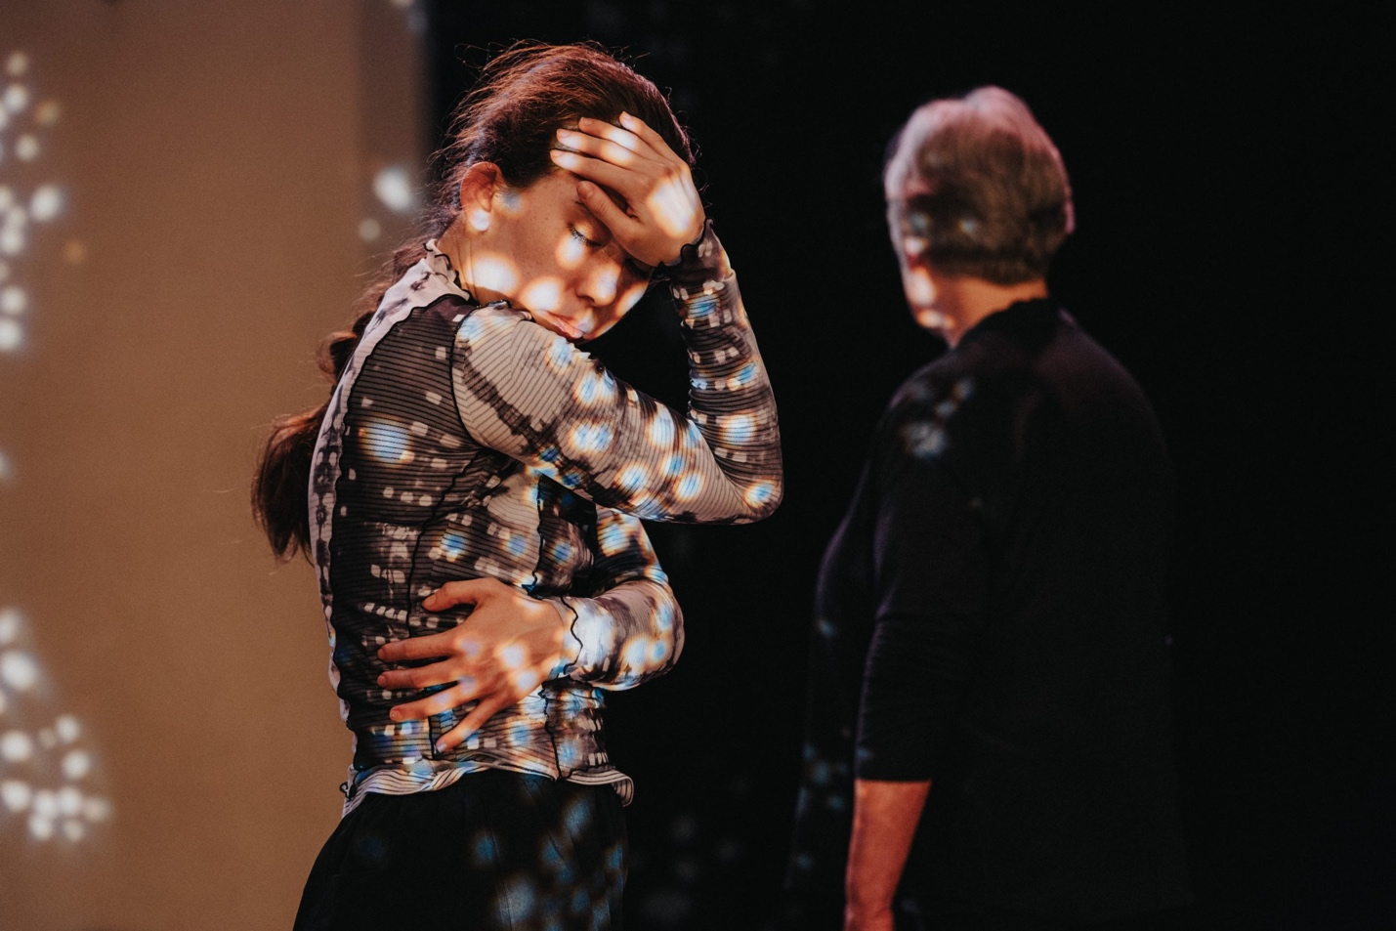

Words by Maxine Flasher Duzgunes.

**San Francisco, CA** – This poem is not a virus. Here, this poem is a dance: of jazz hollowed by the streets, its pedestrians all traipsing at airy distances. Of river wading, between the front door and the world locked outside of it. Of waiting for packages to pile up until a neighbour knocks and wonders whether you’re still alive, inside the ghost of a childhood home.

For three years these thought-containers became our only known homes – tents, tiny apartments, 17-year-old bedrooms unchanged since moving out of them. Canaries in a coalmine, echoed one of many voices drizzling like rain onto five dancers and a dozen elders in hazmat suits, circling the stage.

Diving into a funnel of pandemic narratives, [**Deborah Slater Dance Theatre**](https://www.instagram.com/debslaterdance/)**’s** performance ***In the Presence of Absence*** combined the stories of many into a soliloquy of one. It premiered November 10-12 at [Dance Mission Theater](https://dancemissiontheater.org/), with multiple collaborators including the Cosmic Eldere Theatre Ensemble, Patricia Silver of Word for Word, and Youth Speaks. In gathering stories from these confined times, from those of young people to those of old, the company presented a period of reckoning, of waiting and wondering, unlearning and relearning, binge watching and off-griding, swimming the river and surfing the net, and of asking what comes next?

With original music by Marcus Shelby and sound design by Cliff Caruthers, the dancers are frequently interrupted in their tender duets by the ding-dings of the videogame Animal Crossing, the horns of a bus, and shrill cross-town sirens. The jazz scores by Shelby begin concave, the brass tones rounding out and back like someone swallowing their own fear, and often are hidden behind audio tracks of overlapping voices…heard together but still enduringly solitary.

Later on the music erupts in an organised chaos, a through-line to follow amid the Wonderland dark. As many of the dancers take the stage solo, I imagine the character Alice in each of them, at first charmed by her dream but then regretting it as the forest dims and her sense of direction fades. At the beginning, we didn’t foresee that the world would remain dark for so long. Some had window panes through which they could see the future…but for many it blurred and turned grey with the rain.

*If I don’t make the right decision, I’m doomed forever,*says the voice of a poet caught between the future and the past. Sometimes it’s a gleam of light, sometimes it’s a blaze, he says, like this send-off that we must prepare for ourselves, unknowing of the outcome yet continually walking its rocky road. It’s about elevation, he repeats on and on, the dancer on and off a chair, chest hailing the sky. The poet’s rapped words catch speed as if strung together by the soloist’s climbing motions, arm over arm, hand over hand, yet landing nowhere.

Where did our lives go? I wonder this as some of the last lines of the performance are uttered aloud: forgetting where you end and we begin. A send-off. Towards its start, the dancers line up across the stage like a drawbridge over a river, their grey and white garments wallowing in the muted sounds of a piano in the water. But at its end, it is the elders, a white ray of light embracing the dancers as they depart.

An elder recounts us through images of gloved baristas and germaphobic librarians, CNN on the television 24/7, and endlessly chapped hands. And I realise it’s these annoying details that keep the grief at bay: pining for the subway upheaval of a city that could kill me. It’s about letting the window be the first place where you can see your mom come home from her nursing shift. We are the losers sealing our despair in a bottle on the counter, anything to let the glass shield us from blurring into the pane.

It’s about swimming in the Yuba River once a day. Finding tenderness with the water like we used to know another’s skin. Slater’s work evokes the contours of water, its surface shimmery gold upon descension but blue-green upon immersion…and its textures and temperatures are a question of our relation with the body in which we swim. If we really asked ourselves about whether we could swim here everyday, where do you think the world would be alongside us?

For more information on the company’s work, visit [www.deborahslater.org](http://www.deborahslater.org/) or follow them on Instagram at [@debslaterdance](https://www.instagram.com/debslaterdance/).

* [**TWITTER**](https://danceartjournal.com/2023/11/25/deborah-slater-dance-theater-in-the-presence-of-absence/?share=twitter&nb=1)
* [**FACEBOOK**](https://danceartjournal.com/2023/11/25/deborah-slater-dance-theater-in-the-presence-of-absence/?share=facebook&nb=1)

RELATED

[Boy’s Khaya by Tavaziva Dance | a poem by Jessie Jing](https://danceartjournal.com/2021/11/23/boys-khaya-by-tavaziva-dance-a-poem-by-jessie-jing/?relatedposts_hit=1&relatedposts_origin=6790&relatedposts_position=0)IN "REVIEWS"

[a future for independent dance](https://danceartjournal.com/2020/07/15/a-future-for-independent-dance/?relatedposts_hit=1&relatedposts_origin=6790&relatedposts_position=1)IN "UNCATEGORIZED"

[And by Charlotte Mclean: a courageous dance poem | review](https://danceartjournal.com/2022/08/18/and-by-charlotte-mclean-a-courageous-dance-poem-review/?relatedposts_hit=1&relatedposts_origin=6790&relatedposts_position=2)IN "REVIEWS"

[DANCE MISSION THEATER](https://danceartjournal.com/tag/dance-mission-theater/) [DEBORAH SLATER DANCE THEATER](https://danceartjournal.com/tag/deborah-slater-dance-theater/) [IN THE PRESENCE OF ABSENCE](https://danceartjournal.com/tag/in-the-presence-of-absence/)

Top of Form

Bottom of Form